10-20 GS/s Sampling chip V4

-1 Specifications.

Channels 4 + 1 test + 1 timing
Sampling rate 10-20 GS/s
Analog Bandwidth 1-2GHz
Self or External trigger
Dynamic range 800mV
Sampling window 400ps-800ps (or 8 delay cells)
Sampling jitter 10ps
Crosstalk 1%
DLL Timing generator Internal phase comparator and charge pump, external LP filter
DC Input impedance ½ 50Ω internal, ½ external
Conversion clock Adjustable 500MHz 1GHz internal ring oscillator.
Maximum conversion time 8us.
Read clock 40 MHz. Readout time (4-channel) 4 x 256 x 25ns=25.6 μs
Power 40mW/channel
Power supply 1.2V
Process IBM 8RF-DM (130nm CMOS)

-2 I/Os

Signal Name Type I/O Pad Function

SCA Channels Inputs

signal0-4 aI Analog inputs 0-1V, 50Ω to returns vbias0-4
vbiasl0-4 aI Input return
thresh0-4 aI External Channel Triggers thresholds

15

Channel common digital signals

COMPbypass_sel dI Selects the latch of the ADC counters. Low: Latch_EXT, High: sampling cell
comparator’s output.
Latch_EXT dI External Latch of the ADC counters (regular is sampling cells comparator’s
outputs)
READswitch_cntrl dI Read switch control. Enables the sampling cell voltage onto the
sampling cell comparator.
TRIGsign dI Threshold on negative or positive input transition.
TRIGen dI Selects internal or external trigger
TRIG dI High: freezes the voltage on the sampling caps. Low: the fixed sampling
window (8 delay cells) on channels 0 and 1, the variable sampling window on
channels 2-4 to controls the sampling cells
RO_en dI Enables the RO frequency divider (1:4) to clock the ADC.
RAMP dI Enables the ramp (active low). Clears Cext when high.
ClearADC dI Resets the ADC counters.
ClearTRIG dI Clears the internal triggers responses.
RESET_DLL dI Resets the DLL’s timing generator control voltages
RO_freq_sel dI Selects the ADC clock frequency (divide 1 or 4)

12

Analog Voltages/currents

TRIGbias aI Bias current for the input comparators (triggers).
CEXT aI External capacitor (RAMP)
RAMPbias aI Controls the ramp current (slope).
V2GN aI Controls the ADC ring oscillator frequency clock falling edge
V2GP aI “ “ leading edge
VswN aI Controls the sampling window falling edge
VswP aI “ leading edge
biasDLL_1 aI Controls the charge pump “ups”
biasDLL_2 aI “ “downs”
Ipol1 aI Controls Charge pump for DLL falling edge
Ipol2 aI “ “ rising edge
COMPin_test+ aI Test comparator input +
COMPin_test- aI “ -

13

Clocks/Readout

WriteCLK dI Write clock (40 MHz to timing generator)
Copy_CLKin dI Copy of Write clock
Rd_ck-1-2 dI Read clocks (40 MHz)
Tok_in-1-2 dI Inputs of the token passing
CHIP_oe dI Chip output enable (12 data bus). Active low.
D0-11 dO 12-bit data bus controlled by the tokens (see below) and the
Channel decoder outputs.Tied to ground in the Hi-Z state with a large internal resistor.
Overflow dO ADC’s counters overflo
tokout-1-2 dO Output of the token passing

21

Test outputs

ROmonitor dO Bit #9 of the ADC counter (divide frequency by 1024)
SerialDAT_test dO Serial test data output (ADC’s counter + overflow) available
on token 2 65-77
COMPtest dO Test comparator output
ROfan_test dO Test counter 9th bit buffered output
RAMP_buffer_out aO Ramp test output

5

Trigger outputs

TRIGout_0-4 dO Channel Triggers inputs.
Trigger_or_out dO OR of the Channel Triggers outputs

6

DLL outputs

VDL_out dO Output from VCDL for delay lock
VCN_out aO Rising edge analog output control
VCP_out aO Falling edge analog output control

3

Channel and Token controls address Decoders

ChanX-Y-Z dI Channel address, selects the channel to be read.
0 no channel selected
1-5 channel 1-5
6 clear the ring oscillator monitor counter
7 xx (or channel 6 if implemented)

TokX-Y-Z dI Token control. Readout as 4 blocks of 64/channel (to skip
known off-time data)
0 no block selected,
1-4 token block 1-4
5 clear token
6 clear trig

6

Power supplies
Vdd +1.2V
Gnd 0V

Chip:

81 I/Os
22 Gnd
16 Vdd

119 pads (one unused)

Package CQFP120B:

120 pads

All analog inputs protected with DC path to Gnd and Vdd +/- .6V (5 x 10 μm2 diodes).

-3 Operation Modes

Modes
Write Writes continuously samples of inputs in 60 fF sampling caps arrays at 10-20 GS/s for 25=12.5 ns. Sampling stopped upon internal or external trigger.

Conversion Clears 2 GHz counter, ramps up Wilkinson ADCs for 2 μs.

Read Sequences 256 counters of the channel selected by Chan-0-3 onto the data bus
at 40 MHz read clock rate. Readout can be partitioned into four blocks of 64 caps (token readout) for each channel. Token controlled by three bits (see above)

Test structures

Test structure including a full 12-bit ADC. Outputs read sequentially using the token 2 control.

-4 Layout (to be updated)

Blocks sizes: Timing generator 10 x 12 μm2 x 256
Sampling cell 12 x 100 “
Input comparator 30 x 25 x 4
Comparator 12 x 30 x 256
Counter 12 x 300 “
Token 12 x 40 “
Ramp 100 x 300
Ramp buffer 260 x 65
Ring Oscillator 12 x 50
Divider 12 x 300
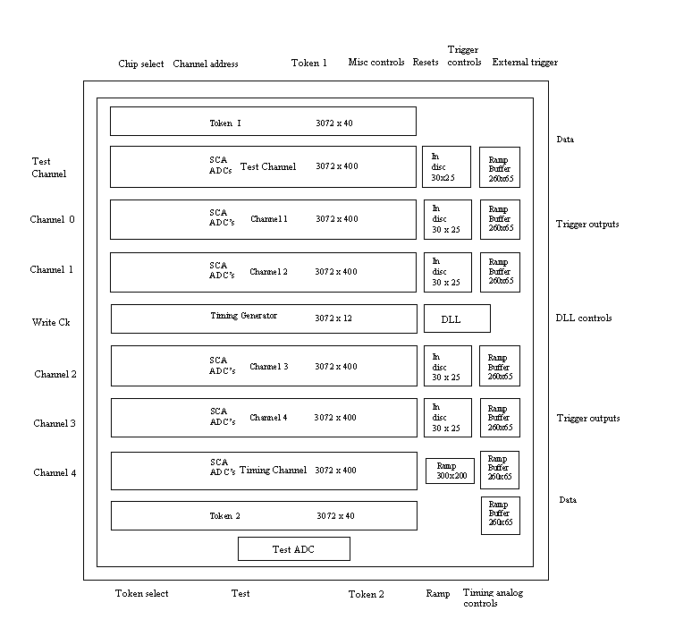

Size: 4500 x 4500 μm2

