Abstract—We describe a FPGA-based, 96-channel, time-to-digital converter (TDC) intended for use with the Central Outer Tracker (COT) in the CDF experiment at the Fermilab Tevatron. The COT system is digitized and read out by 315 TDC cards, each serving 96 wires of the chamber. The TDC, which is implemented as a 9U VME card, has been built around two Altera Stratix FPGAs. The special capabilities of this device are the availability of 840MHZ LVDS inputs, multiple phase locked clock modules, and abundant memory. The TDC system would operate with an input resolution of 1.2ns, a minimum input pulse width of 4.8ns and a minimum separation of 4.8ns between pulses. Each wire input can accept up to 7 hits per collision. Memory pipelines are included for each channel to allow deadtimeless operation in the first-level trigger; the pipeline has a depth of 5.5us to allow the data to pass into one of four separate level-two buffers for readout. If the level-two buffer is accepted, the data are passed through a processor implemented in the FPGA to encode the relative time-to-digital values by using the memory positions and addresses of the transitions due to the input pulses. This processing and moving of the data takes 12 microseconds; the results are then loaded into an output VME memory. A separate memory contains the resulting word count, which is used in performing a VME 64-bit Chain Block Transfer of an entire sixteen-card crate. The TDC must also produce prompt trigger flags for a tracking trigger processor called the Extremely Fast Tracker (XFT). This separate path uses the same input data but passes the stream through a special processor, also implemented in the FPGA, to develop the trigger data delivered with a 22ns clock to the XFT through a high-speed transmission cable assembly. The full TDC design and multi-card test results will be described.
Version: 1.1 Date: 11/4/2004
A 96 Channel FPGA-based Time-to-Digital Converter
Mircea Bogdan, Henry Frisch, Mary Heintz, Ting Miao, Alexander Paramonov, Harold Sanders,
and Peter Wilson

INTRODUCTION
The Collider Detector at Fermilab (CDF), is a large (5000-ton) detector of particles produced in proton-antiproton collisions at 1.96 TeV at the Fermilab Tevatron. The detector consists of a solenoidal magnetic spectrometer surrounded by systems of segmented calorimeters and muon chambers. Inside the solenoid, precision tracking systems measure the trajectories of particles; the particle momenta are measured from the curvature in the magnetic field and the energy deposited in the calorimeters. The tracking systems consist of a silicon-strip system with >750,000 channels around the beam-pipe, followed by the Central Outer Tracker (COT), a large cylindrical drift chamber with 30,240 sense wires arranged in 96 layers divided into 8 “superlayers” of 12 wires each. Four of the layers have the wires parallel to the beam axis; the remaining four are tilted by +- 3 degrees to provide small-angle stereo for 3D reconstruction of tracks. The maximum drift time of the COT is ~200 nsec; the maximum drift length is 0.88 cm.
During the present Run II, the peak luminosity of the Tevatron has grown to well over 10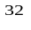, a factor of more than five higher than in Run I. The Tevatron operates with 396 nsec bunch spacing, with the result that the occupancy (hits/channel) in the COT increases with luminosity as the number of proton-antiproton collisions per beam crossing is now greater than one. The increased occupancy puts a load on the rate at which CDF can record events to permanent media. While CDF is operating at its design readout bandwidth, there are still more good events than can presently be logged, particularly due to the success of the Silicon Vertex Trigger (SVT), which has given us a new capability to trigger on events from b-quarks. A broad range of efforts are underway to upgrade the readout bandwidth to allow operation at luminosities up to 3x10, including the development of a new time-to-digital converter (TDC) for the COT.
In this note we describe the design of a new TDC for the COT based entirely on FPGAs. Four working prototypes have been built and tested. Thirty-five preproduction boards have been ordered for full-crate tests this summer. A suite of test routines has been implemented, and a custom test card with 96 independently controlled output channels is under construction.

Principle of operation
The Time-to-Digital conversion is implemented with Altera Stratix FPGAs. This device has an LVDS differential I/O interface which consists of one dedicated serializer/deserializer (SERDES)[1] circuitry for each differential I/O pair. Serial data are received along with a low-frequency clock. An internal PLL multiplies the incoming clock by a factor of 1 to 10. The resulting, high-frequency clock shifts the serial data through a shift register. The parallel data are then clocked out, synchronized with the low frequency clock.
In this application the low-frequency clock is internally generated with a 12ns period and the SERDES factor is set to 10, for a resulting 1.2 ns sampling rate of the incoming LVDS signal. Figure 1 illustrates the principle of the Time-to-Digital conversion, as seen in the Quartus II [2] simulation window.

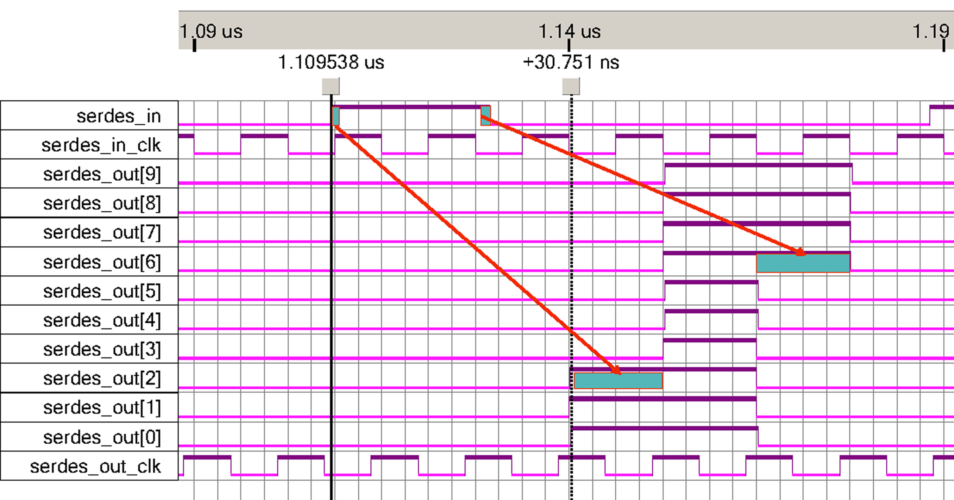
Fig. 1. Principle of Time-to-Digital conversion: the input LVDS pulse is converted into a 10-bit data stream.

The input pulse is converted into a 10-bit data stream, serdes_out[9..0], moving on a 12ns clock period. The leading edge is determined by counting the number of “0” bits before the first “1” bit of a string of at least four “1” bits. The pulse width is calculated by counting the number of successive bits until a string of at least four “0” bits occurs.

TDC Board – Block diagram
The block diagram and the data flow on the board are presented in Figure 2.
On the front panel, the board has 96 differential inputs, 48 for each FPGA (TDC Chip), which receive pulses from the COT. The signals are first applied to a repeater block that converts them into standard LVDS and passes them directly to the two FPGAs, which have identical designs.
The two TDC Chips receive the COT pulses and generate the Hit-Count and Hit-Data results in the internal VME Readout buffers.
The TDC Board is designed to function in existing standard CDF Readout Crates and uses specific backplane signals [3] generated by the CDF Trigger System(TS) Interface, Tracer and Master Clock as follows:
- the CDF system clock – reference 132ns clock for all TS logic;
- the Live Beam Crossing signal;
- the Bunch 0 signal – marks the 0th bunch which comes once per cycle around the ring;
- the Level 1/2 words – present the Level l/2 Accept/Reject messages, as well as the Level 2 Buffer address bits;
Other CDF signals are routed to the two FPGAs on board to allow future firmware design reviews.
Trigger flags used by the eXtremely Fast Tracker (XFT) to identify tracks in the COT are also generated and sent out via the backplane connector P3 through a set of tri-state buffers.
The VME interface block is also implemented with an Altera FPGA. It coordinates VME access to the TDC Chips for regular and Chain Block Transfers (CBLT) [4] in both 32-bit and 64-bit modes. The VME Chip itself connects only to the 16 LSB of the VME data bus.
The CDF Clock from the backplane is first converted to TTL with a PECL receiver, then phase-locked, buffered and applied to the TDC Chips directly and also through a pair of programmable delay lines.
Each FPGA on board is connected to a 20-pin header for logic analyzer hook-up.

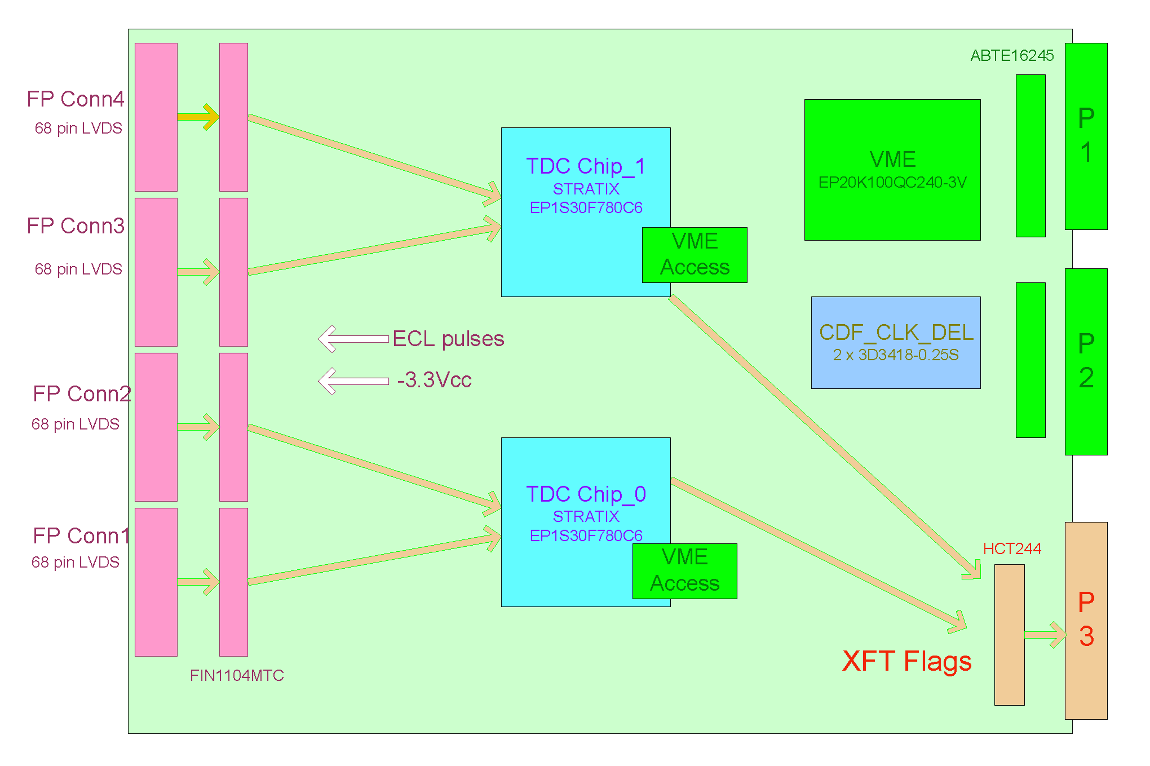
Fig. 2. TDC Board - Block Diagram and Data flow: the Front Panel (FP) connectors receive 96 differential LVDS pulses that are buffered and passed to the two FPGAs for processing.

TDC chip
The block diagram of a TDC Chip is presented in Figure 3.
There are two major data paths inside the TDC chip, one for edge detection and one for TDC/XFT primitives generation. The chip is also provided with a Test Data generator, a LVDS pulse generator and a PLL clock generator.
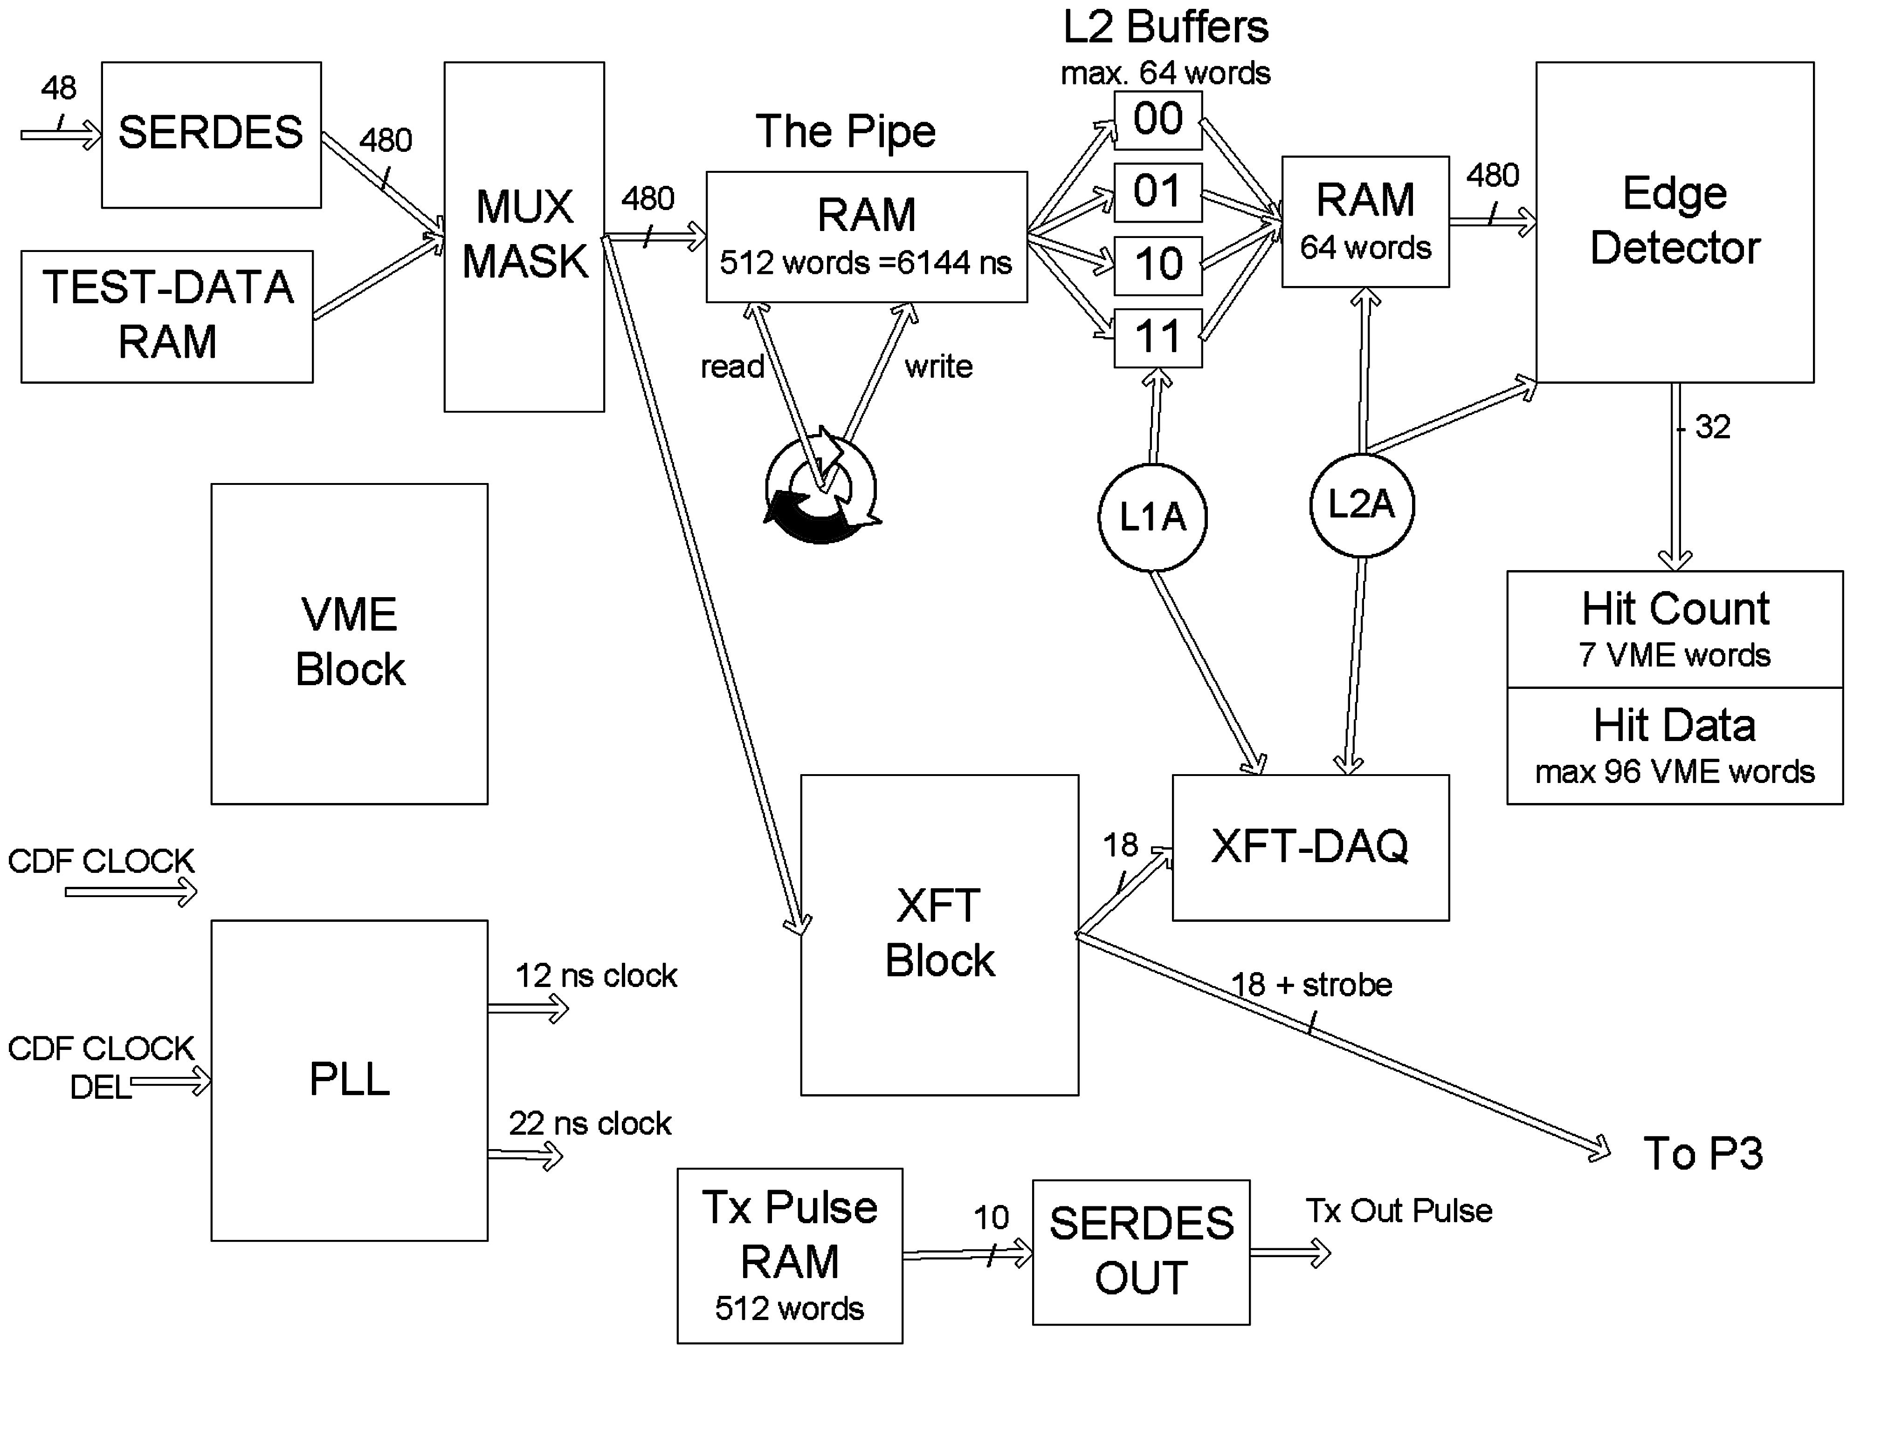

Fig. 3. TDC Chip - Functional Block Diagram.

All the major functional blocks inside the TDC chip are presented individually.

The Input Block
Each TDC Chip has four banks of 12 high-speed LVDS inputs. From each bank, a 120-bit wide data bus is passed along to the MUX/MASK block, which can block out any unwanted channel. The schematic the input block for one bank is presented in Figure 4.
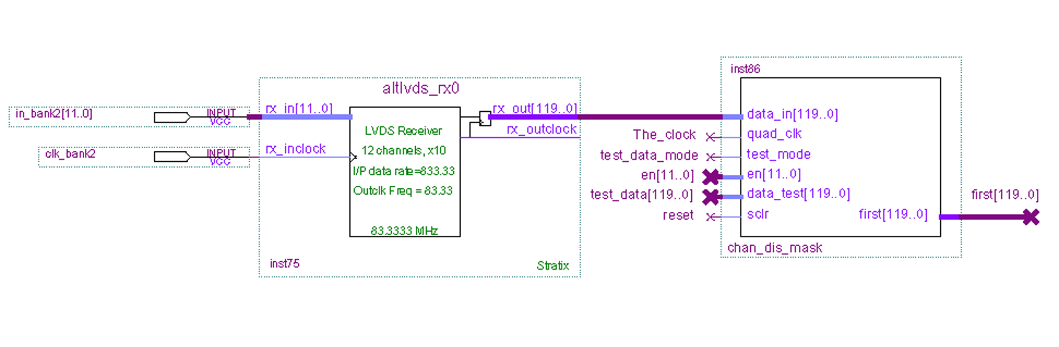
Fig. 4. Input bank schematic: the Altera altlvds_rx megafunction implements the deserialization receiver.

The MUX/MASK block also makes the selection between the signals from the COT and a test pattern generated inside the chip with the Test data generator block.

The Delay Block and The Level 2 Buffer System
Upon a Level-1 Accept (L1A) trigger pulse, data pass through a 512x480 RAM, the Pipeline, and is written into one of the four Level-2 Buffers. The write and read addresses for the Pipeline come from the same, 9-bit, circular counter. The difference between those two values is controlled via VME and corresponds to the actual time difference between the L1A pulse and the moment at which the signal that gets stored in the Level-2 Buffer reaches the TDC chip. The writing of each Level-2 Buffer is independent; therefore the chip accepts L1A pulses on each CDF clock edge. There is no data loss if one starts writing of a Level-2 Buffer before the writing of another one has ended. The number of words written in the Level-2 Buffer is set with a VME write command. A Level-2 Accept (L2A) trigger pulse transfers data from the selected Level-2 Buffer into another, identical memory and then to the Edge Detector Block. The second RAM is required in order to free the Level-2 Buffer for a new L1A pulse.

The Edge Detector Block
The Edge Detector Block is made up of two modules. The first, called ED, finds and stores the edges on each of the 48 wires. The second, called ED48, controls when data moves into the block, collects and packs all the found hit data together and signals when the block is finished. Each wire has its own dedicated ED, making 48 on each Stratix chip, while there is only one ED48 on each chip.
The data from the Level-2 Buffer is fed into the Edge Detector Block, in 10-bit words. A single ED looks for hits by working with two 10-bit words at a time. The beginning of a hit is defined as a zero followed by at least four ones, or in the case of the first word, four ones in a row. The end of a hit is defined as a one followed by four zeroes.
Figure 5 shows the relationship between the position of bits in the words sent to ED and their respective time value.
Fig. 5. Time definition of data in ED. Each time value represents a 1.2 ns interval, as each word covers 12 ns.
There are three possible transitions in each word and each transition needs a memory cycle. Figure 6 shows a word that has three possible transitions.
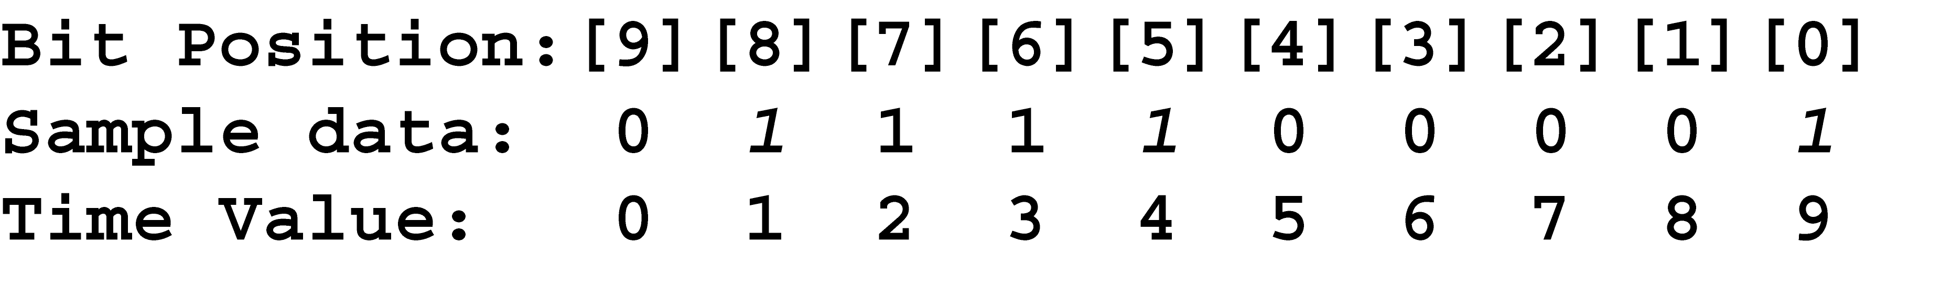
Fig. 6. Sample word showing three possible transitions in data word sent to ED.
In this case, there is a leading edge (transition #1) starting at time value 1 and ending at time value 4 (transition #2). There is also possibly another leading edge (transition #3), starting at time value 9, depending on what is in the next word. This is why ED looks at two words at a time. In the example above, it would check if the next word started with three ones.
Once a hit has been found, the data describing the hit (hit data) must be stored and a running total of how many hits found (word count) must be kept. Each ED has a little ram for storing the hit data. The hit is stored by giving the time value of the start of the hit (the leading edge) and the number of bits in the hit (the width). So, if the above example were the first word in the data stream, the leading edge stored would be one and the width would be four. If the example were the third word, the leading edge would be 21 (10 bits each for the first and second words and time value one in the third) and the width would still be four.
The maximum number of words that will be looked at for each wire is variable, but it will not exceed 33 words (396/12). This is because it takes 12 ns for each word (1.2 ns per bit times 10 bits per word) and the maximum run time is 396 ns. The actual number that has to be searched is variable and is an input to ED.
The maximum number of hits stored is seven. Each ED has two little rams that hold the leading edges and widths. These reams are called le_ram and width_ram and each can hold eight 8-bit words. Eight-bits limits the leading edge values to 255 and less, but this is sufficient for the 306 ns drift time (255 x 1.2 ns). For reasons to be explained later, the largest leading edge will actually be 254. However, ED will continue to look through bits after 254 to find the width of any hits that did not finish by bit 254.
As described previously, ED looks for transitions in three groups. The first group (A) looks for a specific pattern starting in bits 9-6, the second group (B) looks at bits 5-2 and the third group (C) looks at bits 1-0. The exact pattern to match depends on whether it is looking for a leading or trailing edge.
There are four different clocks that are used in ED. Their characteristics are given in Figure 7. Figure 8 graphically shows the clocks and the tasks performed during the different states.
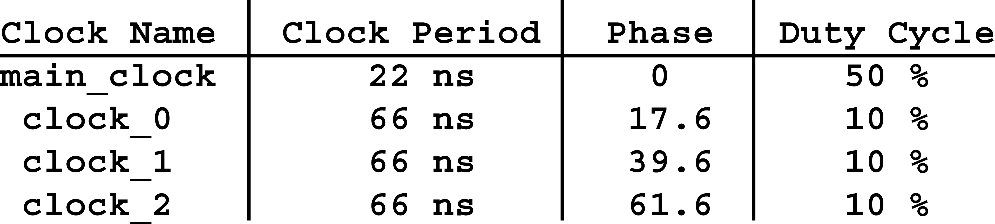
Fig. 7. Characteristics of clocks

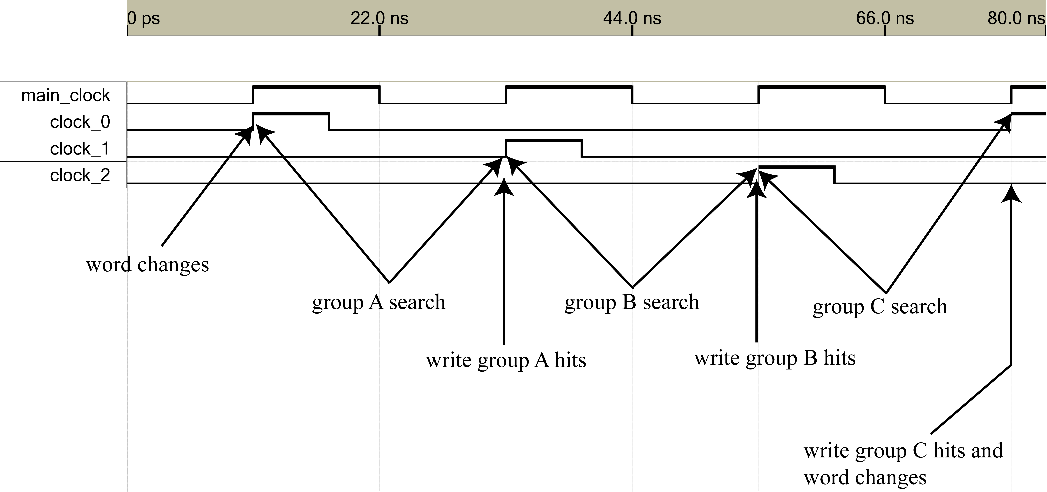

Fig. 8. Graphical representation of clocks used in ED and the processes that occur during each state.

Figure 9 shows data that will be used as an example-the hits are shown in bold. Beneath each bit is the time value that would be stored (in le_ram) as the leading edges of the hits.
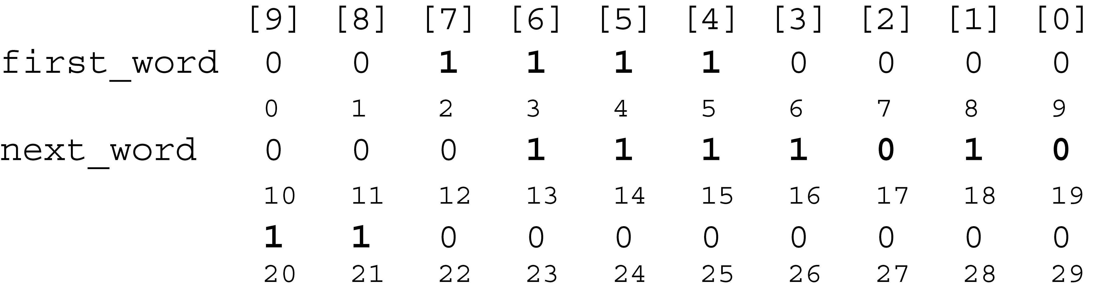
Fig. 9. Sample data showing hits ED would find.
In order to look at hits that might wrap around the edges of words, ED must look at two words at a time. It has two buffers, called first_word[9..0] and next_word[9..0], that it uses to hold the two words. It also has a state machine that it uses to determine which group of bits it is searching. The states are called a_state, b_state, and c_state.
In the example data, ED first searches for the pattern starting in the group A bits (bits 9..6). Figure 10 shows the logic for searching group A.
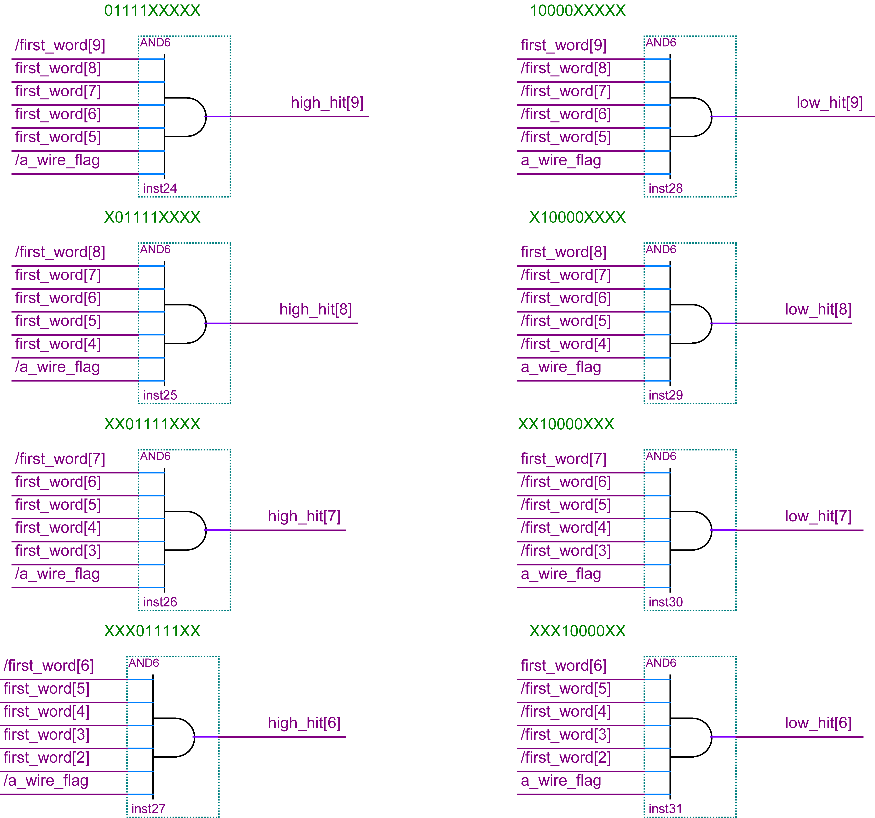
Fig. 10. Logic for finding leading and trailing edges in group A.

Since this is the first word, the pattern that is being searched for is the one that represents the leading edge. The pattern is “01111”, and it is found starting at the first word. The signal high_hit[8] is now set and used with the other high_hit[X] signals to decode the ones digit of the hit. Figure 11 shows how the position is decoded to a binary value, which is stored in le[X]
Fig. 11. Logic used to decode time value to binary.

Since this hit is in the first word of the example, the signal le[X] contains the correct value for the time value of the leading edge. However, if this hit were in any other word, this value would be incorrect. The correct time value of the hit is found by multiplying the address of the word by ten and adding the value in the signal le[X]. This calculation is slightly more complex in the schematic because the read_address value sent to the Level-2 Buffer is the value used for the word address. But since the data that comes from the ram is registered, the value sent as the read_address must be delayed. Plus, the data first goes to the next_word buffer and then to the first_word buffer. The result is that the value four must be subtracted from the read_address signal to get the correct value. And there is a special case where the hit is found in the first four bits of the next_word buffer. In this case, only three is subtracted.
Once the leading edge is calculated, it will be stored in the ram (le_ram) on the next clock. The leading edge is also stored in a signal called subtract_edge, so that it can be subtracted from the trailing edge value to find the width of the pulse. Finally, a flag is used to say that a leading edge has been found and now ED should be looking for the trailing edge pattern, “10000”.
On the next main_clock signal, ED changes to looking for the trailing edge pattern in the group B bits. The pattern is found starting at first_word[4]. Using the same techniques that were used in group A to find the leading edge, the trailing edge is found. The only extra step is that the leading edge must be subtracted from the trailing edge to determine the width of the hit.
On the next main_clock, the data is written to ram and ED looks for another leading edge in the group C bits. In the example data, there is no edge to be found in the group C bits, so no data is written, the words change and the process repeats.
This process repeats until the number of words that were specified as an input to ED have been read. At this point, if ED is looking for a trailing edge, it writes all ones to signal that it didn’t find a trailing edge for the last hit.
Finally, here are a few other notes on ED. The two memories, le_ram and width_ram, are separate so that when writing their contents to a bigger memory (in the ED48 step), a 16-bit bus can be used, instead of an 8-bit bus. Along with the rams, there is an output bus called word_count[3..0] that gives a final total for how many hits were found. At most the number of hits is going to take three bits. The extra bit is connected to a pin named wire_off, which is used to tell whether a wire was on or off during the run. The largest value of a leading edge is 254 because the last possible time value of a hit in group A is three. Any leading edge with a value of 255 would start in group B. But if this were allowed, values 256, 257, etc. could also possibly occur. In order to prevent time values that cannot fit in 8 bits, it was decided that the largest leading edg time value would be 254.
The second part of the Edge Detector block is the module called ED48. Its job is to take the data from each ram in each ED and pack it into two bigger rams. One ram, called hit_count_dualport, holds the number of hits that were found on each wire. The other ram, called hit_dat_dualport, holds the hit data.
ED48 starts with a Level 2 Accept. Then, if it is not already reading data from the Level 2 Buffer, it starts to do so. If it is already reading from the Level 2 Buffer, the Level 2 Accept is ignored. ED48 sends a signal to each ED to clear its buffers and then sends a signal to the Level 2 Buffer to start sending data. At this point, ED48 does nothing until all the EDs are finished working.
ED48 starts by summing up the word counts from each ED. This sum is the number of 16-bit words that will be written in the hit_dat_dualport ram. Since the data will be taken out of the ram on a 32-bit bus, the 16-bit word count is divided by two. This gives the number of 32-bit words that will need to be read to get all the data.
Along with summing the word counts, ED48 also starts a couple of counters when the EDs are done. One three-bit counter is used as the read address signal sent to the little rams in each ED. This counter counts up to the number of hits that each ED was to search for and is specified as an input to ED48. The maximum value is seven.
In order to move the data as quickly as possible from the EDs to the hit_dat_dualport ram, ED48 was organized into four sections, each holding 12 EDs. Then, four 12-input multiplexers were used to stream the data from the little ED rams to the hit_dat_dualport ram in ED48. This allowed data to be written on each clock and required only one extra clock cycle when changing EDs. Figure 12 shows the multiplexers used to control the leading edge data.
There are twelve 12-input and three 4-input multiplexers used to control the flow of data from the EDs to the rams in ED48. One 4-input and four of the 12-input multiplexers are used each for the leading edge data, the widths and the word counts.
The second counter that ED48 starts when the EDs are done is a 4-bit counter. This counter controls the selector for one of the 12-input multiplexers. The output of this counter is also delayed three clock cycles. The output of each flip-flop used for the delay is the selector for each of the other multiplexers.
The third counter that ED48 starts is a 2-bit counter which is used to control the 4-input multiplexer. The last counter is an 8-bit counter used to control the read address bus on the hit_dat_dualport ram.
The combination of counters and multiplexers control the flow of data from the little rams in each ED to the hit_dat_dualport in ED48. The number of words read from each ram is constant and equal to the number of hits specified. It does not matter if no hits were found on a particular wire. If the number of hits to search for was specified as six, then six words will be read from the little ram in each ED. At this point, ED48 uses the word count from each ED to determine when the write enable signal on the hit_dat_dualport should be turned on and off.
The write enable signal is mainly controlled by the output of a compare megafunction, which compares the address sent to the little rams with the word count for that particular wire. The only trick here is that one has to be added to the address before it is compared to the word count because addresses in the rams start with zero.
Once ED48 is finished getting the data from each ED, it sends a signal out to clear all of its counters and flip-flops and sets the signal TDC_DONE. This signals that the data is ready to be read out of ED48’s memories via vme.
In ED48, there is also a section with signals called save_wc, write_wc, and clear_wc. These all have to do with the word counts that are written to the hit_count_dualport ram. When the EDs are finished working, the hit count for each wire is known and can be written to hit_count_dualport. So, one clock after the EDs are done, the word counts are registered onto the bust to hit_count_dualport and on the next clock, they are written to the ram, along with some other information required. When ED48 is finished, this bus is cleared along with the rest of the signals.

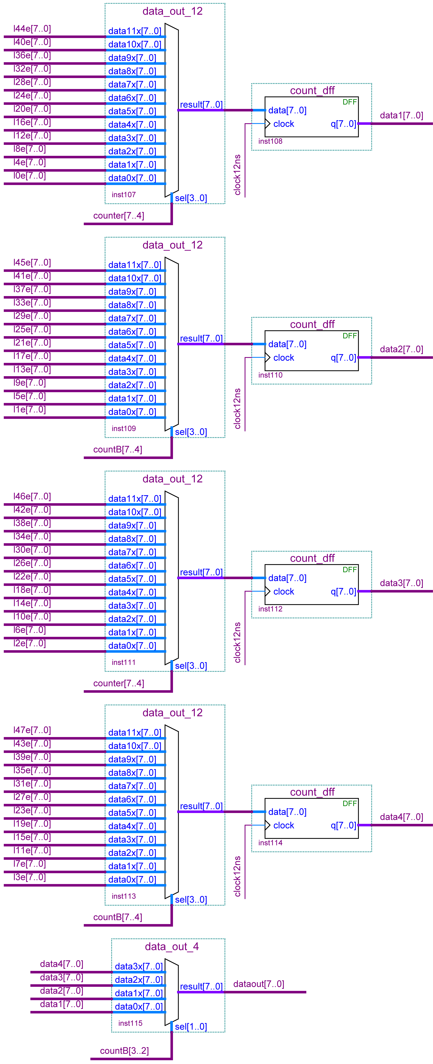
Fig. 12. Multiplexers used to control leading edge data.

The XFT Block
The TDC XFT block generates trigger primitives that are used by the eXtremely Fast Tracker (XFT) to identify tracks in the Central Outer Tracker (COT). COT wires get hit when a particle comes nearby. This produces an electric pulse on a wire. Parameters of the pulse are used by the XFT to reconstruct tracks for CDF physics triggering.
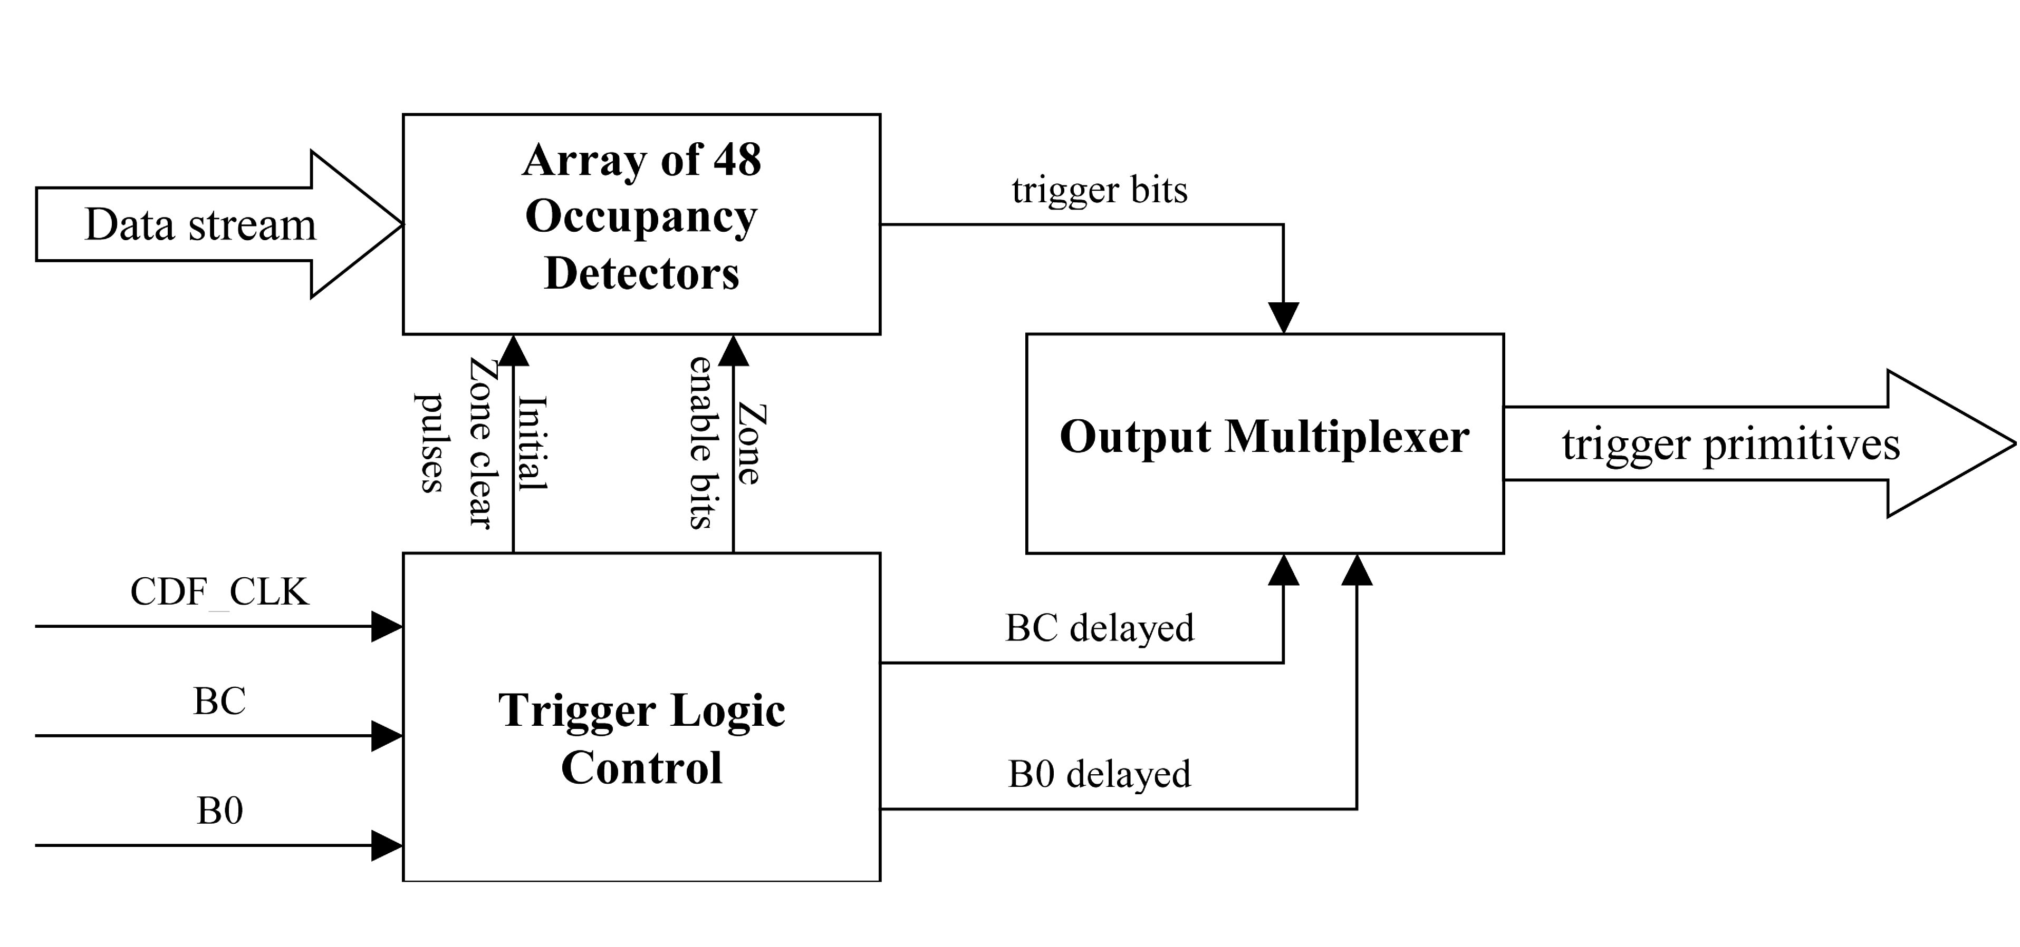
Fig.13 Block diagram of the TDC XFT LogicThe data stream comes from the TDC as 480-bit words every 12 ns. TheCDF_CLK, BC and B0 signals are CDF-specific clocks and pulses. The TDC XFT block sends out trigger primitives that are multiplexed trigger and trigger control pulses.

The TDC XFT block receives a stream of 480-bit words (10-bit word per wire by 48 wires) with 12 ns period. The logical block “Array of 48 Occupancy detector” contains 48 “Occupancy detector” blocks. Each “Occupancy detector” block looks at the data from a particular wire and forms 6 trigger bits for the wire. These trigger bits are sent to the “Output Multiplexer”, which forms the trigger primitives and drives them to the P3 backplane. The “Output Multiplexer” sends out single-ended TTL levels every 22 ns (i.e. 6 times per 132 ns and 18 times per 396 ns). Also it sends out alignment and control signals, that are “Beam Zero” (B0), data “Word Zero” (Word0), and a data strobe.

The XFT Occupancy detector
A single “Occupancy detector” looks for hits in the first 6 ns and the last 6ns of every 12ns interval. A hit is defined as 4 ones in a row (“1111”). Once a hit has been found, the register for the corresponding input 12 nsec time-window sets to “1”. Every register can be enabled or disabled for selected time-intervals. Also any trigger can be enabled only for the first 6ns, the last 6ns (of 12 ns), both 6ns intervals or just disabled. These allow having 6ns precision for the time window ranges. The “Occupancy detector for a single” block for a single wire has the following structure shown in Figure 14.
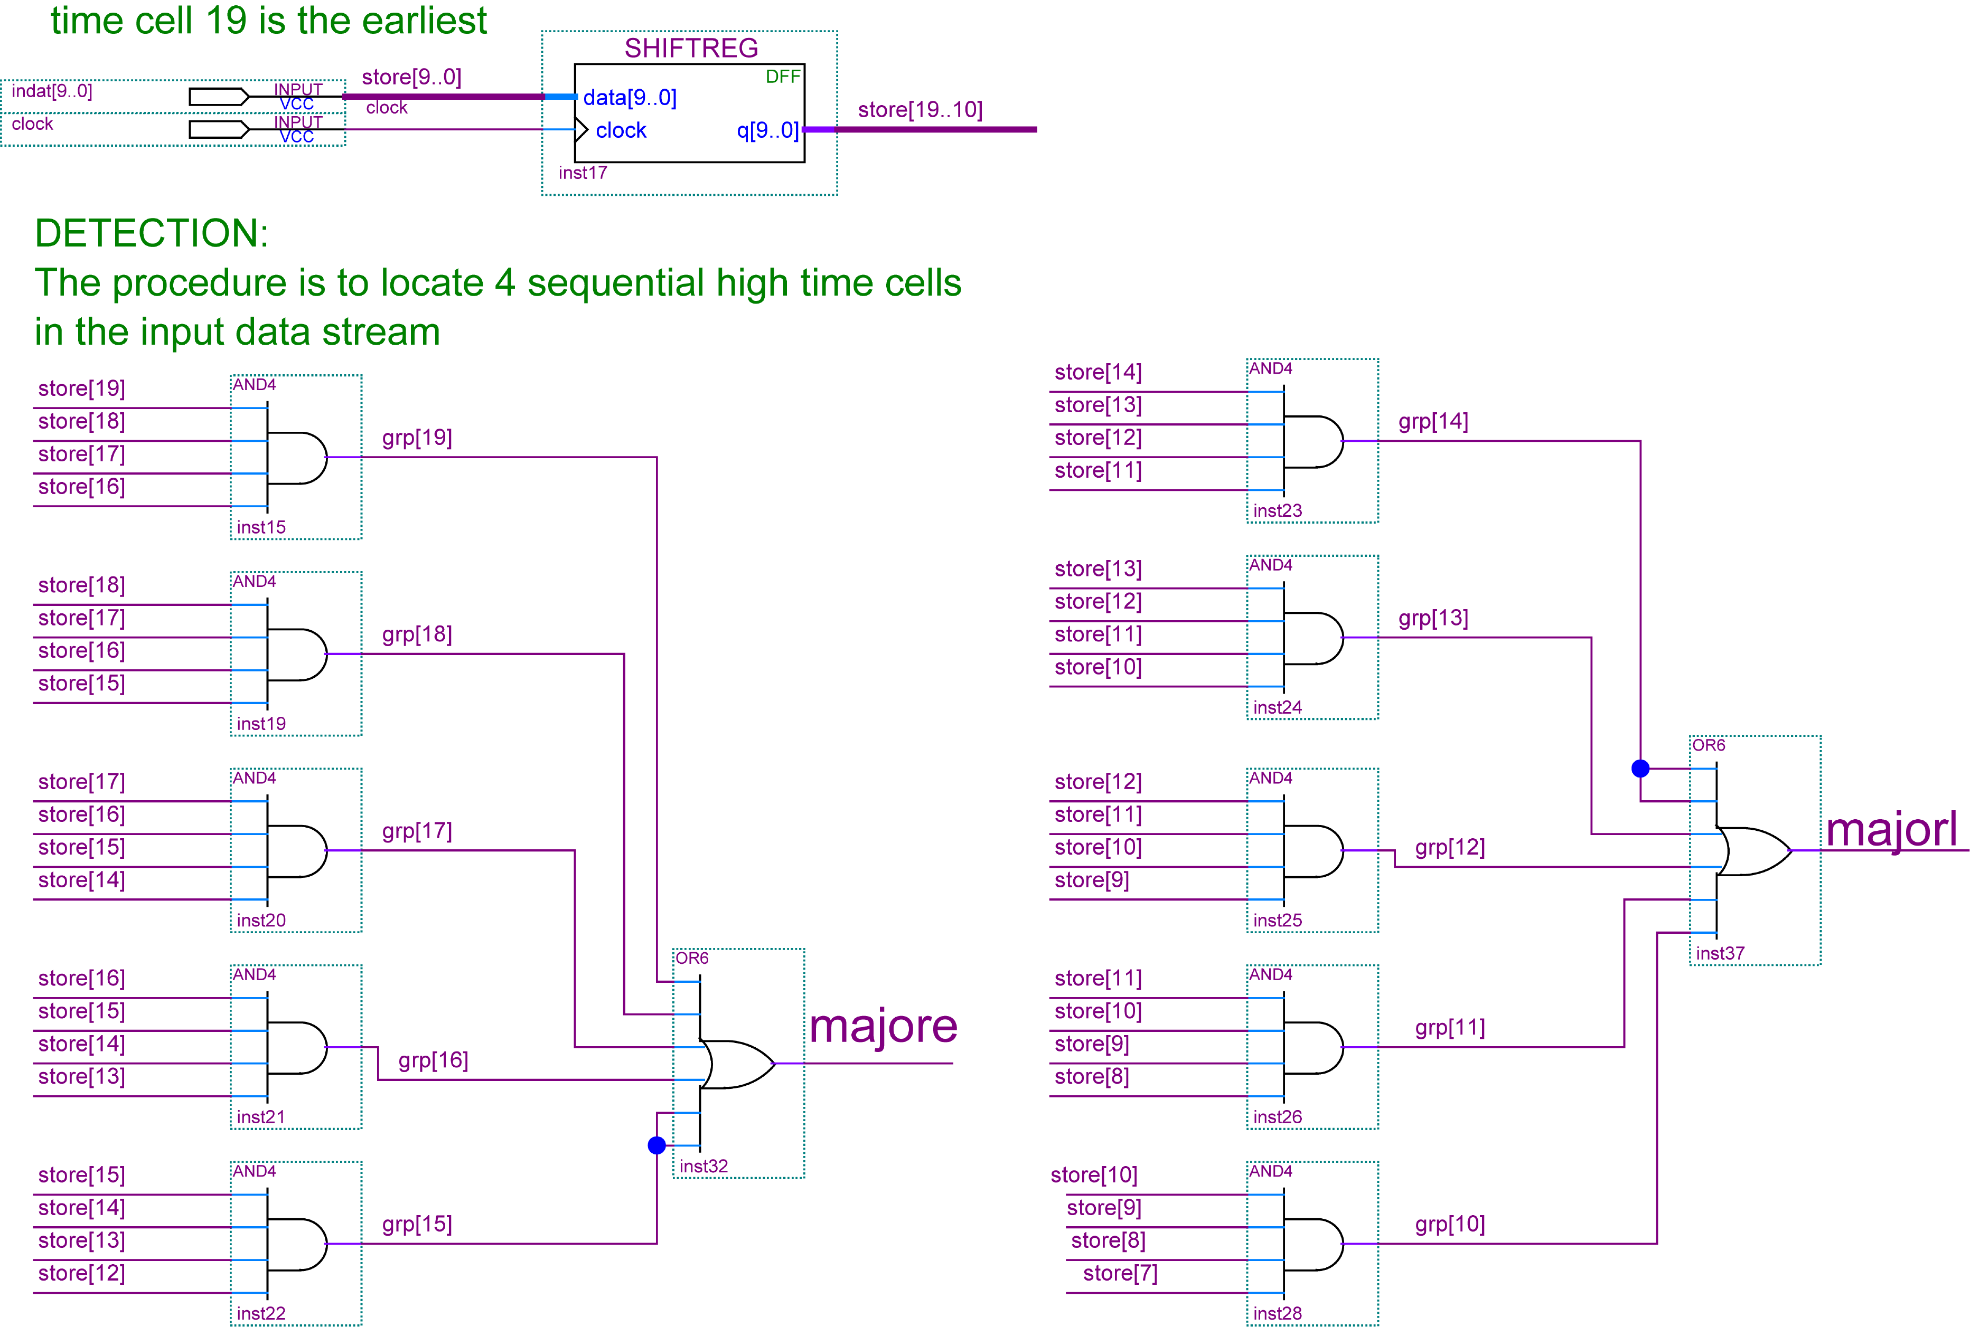

Fig. 14. XFT Hit Detector (Hit Scanner)The “indat[9..0]” is an input data stream for a single wire. Data comes with 12 ns clock. The “majore” and “majorl” are high or low if a hit is occurred in the corresponding time interval (the first or the last 6 ns of every 12 ns).

In Figure 15 we have a hit scanner for a single wire. If a hit is in the first 6ns “majore” is high. Similarly, if a hit is in the last 6ns (on the every 12ns interval) “majorl” is high. “store[9..0]” is an input data stream for a single wire. “Clock” is a 12 ns clock.

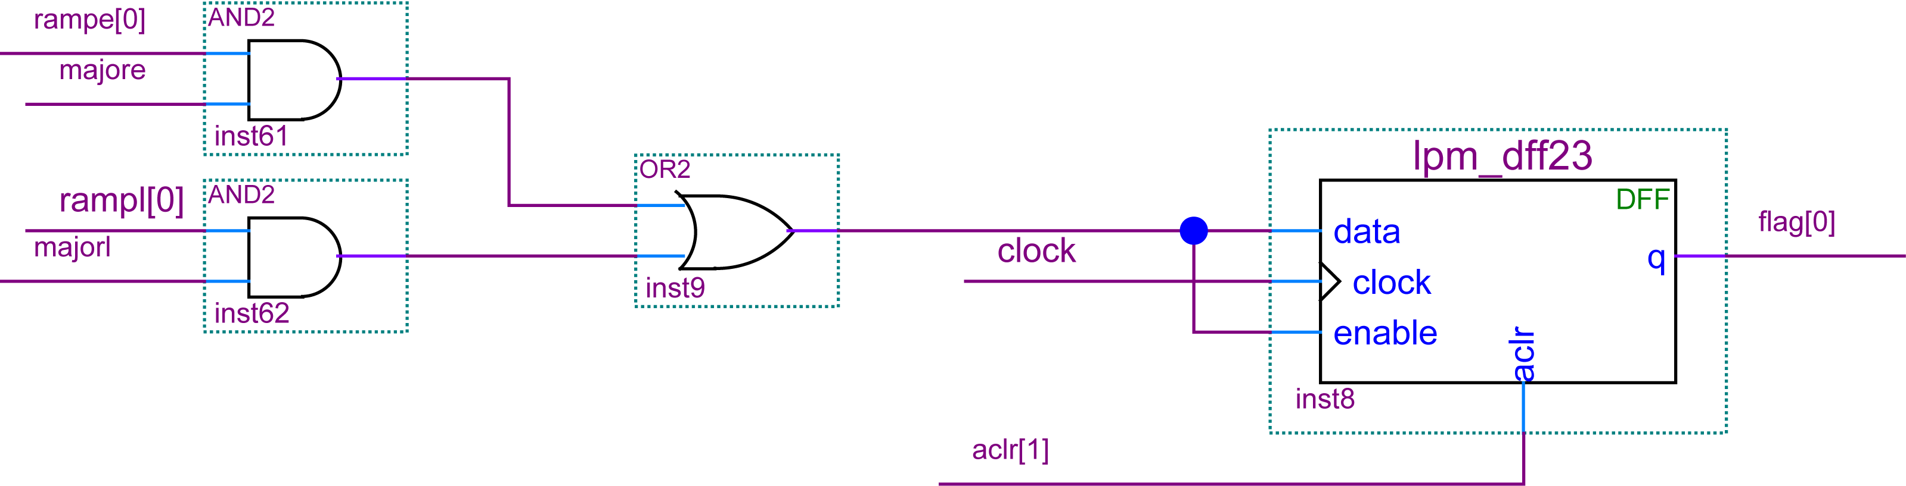

Fig. 15. Initial time zone register The “rampe[10..0]” and “rampl[10..0]” are control signals which come from the Trigger Logic Control block. The “mojore” and “majorl” signals correspond to the XFT hit detector bits. The “aclr[6..0]” comes from the Trigger Logic control block once per event to clear the corresponding group of registers. The “flag[10..0]” bit corresponds to an occurrence of a hit in a time region of interest.

The “Initial time zone register’s sensivity to hits from the first or the last 6ns time interval is controlled by “rampe” and “rampl” signals which are synchronous with the BUNCH_COLLISION pulse. These ramp signals are formed by “Trigger ramp” block and programmable via VME. The eleven bits (“flag[10..0]”) are combined into 6 output trigger bits by the Output Hit Logic shown in the figure below.

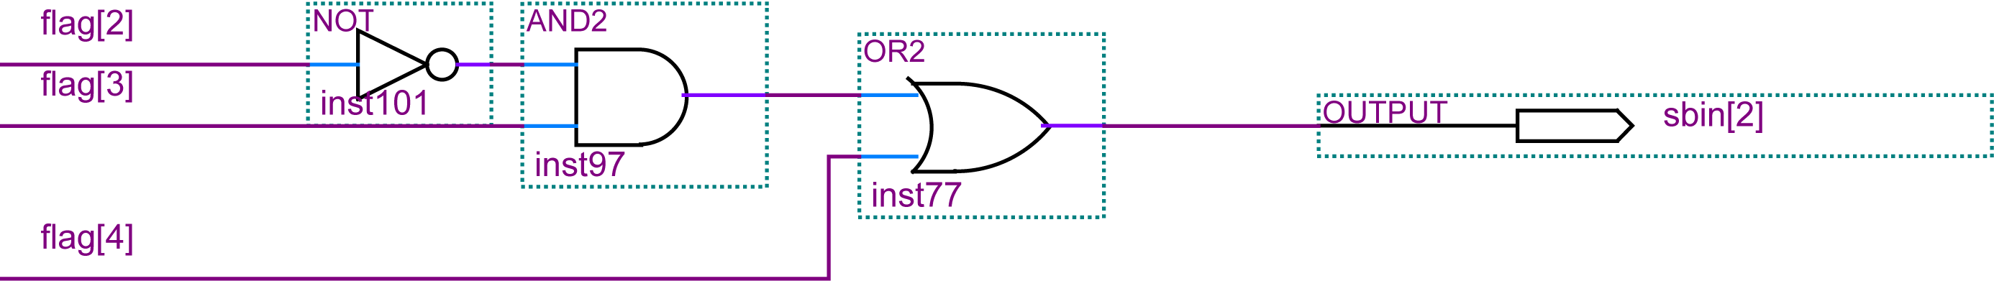

Fig. 16 Output Hit Logic The “flag[10..0]” comes from initial time zone registers. The “sbin[5..0]” flags are actual trigger bits which are sent to XFT after multiplexing.

This Output Hit Logic allows forming of various trigger primitives for the XFT by programming input time zones.

Trigger Logic Control
The “Trigger Logic Control” block controls time-window registers enabling and clearing. It has VME accessible RAM, which contains flags to enable/disable “Occupancy Detector” block time-windows. Also this block is responsible for delaying B0 and BC pulses. All output signals are synchronous to the incoming CDF “Bunch Crossing” (BC) pulse so that for a BC pulse there will be only one set of the output the Trigger Logic pulses. The BC and B0 delayed pulses are by the Output Multiplexer block to generate XFT control bits. The Address Counter starts to count after it receives a pulse from the XFT start delay line. At the same moment the pulse from XFT start delay line comes to the XFT output delay line. The delayed BC pulse comes out on 22ns clock so that it is synchronous with the Output Multiplexer clock. Also the BC delayed pulse initiates trigger primitives sent out by the Output Multiplexer block. The block-diagram of the Trigger Logic control you can see in the figure below. As a result, the time delays can be adjusted in a way to send trigger primitives as soon as possible.

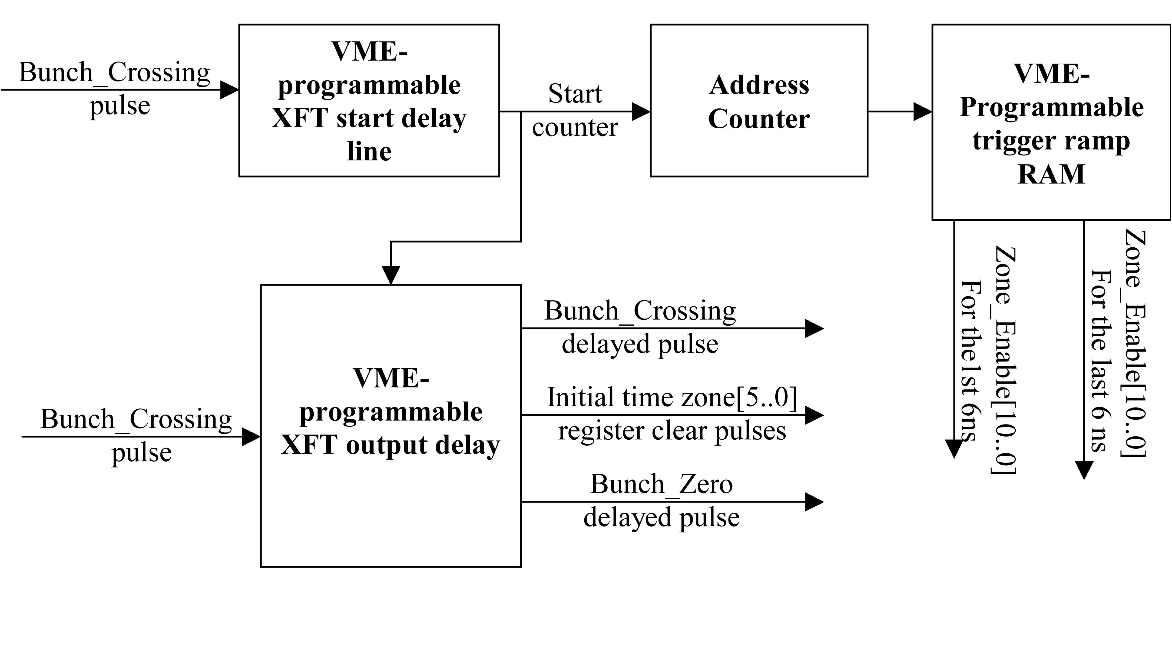
Fig. 17 Trigger Logic Control block-diagramThe “ Bunch Crossing” (BC) is a CDF control pulse, which comes at the time that the proton and antiproton beams cross at the collision point, precisely at 396 nsec. Therefore, all outp pulses are synchronous with the BC pulse. The “Bunch_Zero” (B0) pulse comes on every CDF zero collision and it is synchronous with BC pulse.

Input Bunch_Crossing pulse is synchronous with CDF_CLK_DEL (396 ns clock) and “Bunch_Crossing” delayed pulse is synchronous with 22ns clock. “rampl” and “rampe” flags come with 12ns clock.

Output Multiplexer
The Output Multiplexer sends out a 16 bit trigger-primitive word every 22 ns. Also it sends synchronously a data strobe, a data word zero marker and B0 marker if appropriate. The data strobe runs continuously with a 44 ns period and is coincident with data. The “word zero” is generated at the beginning of every transmission of trigger bits. The “B0” marker is sent out for 6 words of “beam zero” event

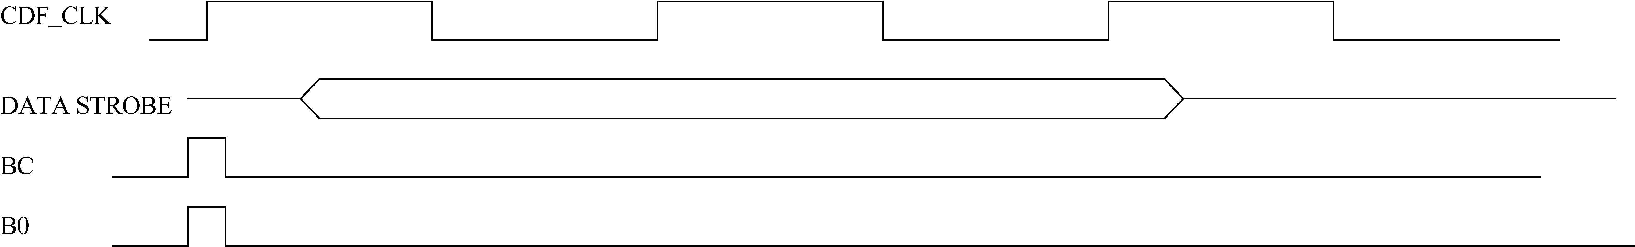

Fig. 18. Input CDF clock and pulses timing diagram for a single bunch crossing.

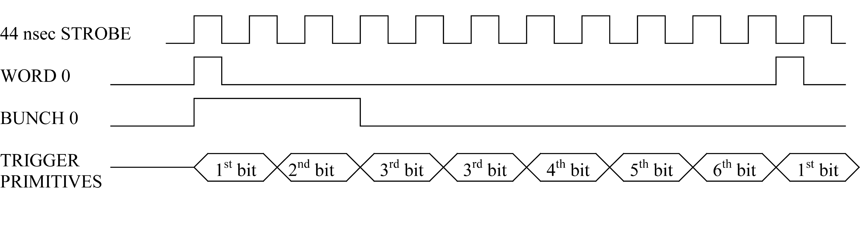
Fig. 19. The TDC XFT output timing diagramm

TDC XFT-DAQ block

The TDCXFT block connects to a dedicated DAQ system similar to the main one. It has the same Pipeline/L2Buffers/VME-Readout Buffer structure and follows the same L1A/L2A sequence as the hit-data stream. The length of the XFT-L2 Buffers is also VME controlled. The XFT-DAQ is used for testing purposes only. Also for testing, the XFT block is fitted with another simple VME Readout RAM that contains the current XFT flags. This RAM can be frozen and read out via VME for diagnostic tests.

The Test data generator
The Test Data Pattern Generator inside the TDC Chip is actually a VME accessible dual port, 480-bit wide RAM. It can store 8192 words. In Test-Data Mode, the reading of the RAM is synchronized with the CDF_B0 back-plane signal.

The LVDS Pulse Generator
The SERDES OUT block (Figure 3) generates an LVDS pulse pattern, used for testing. The number of successive pulses and the timing is controlled via VME by writing the content of the Tx PULSE RAM.

The Clock generator block
The PLL block generates the 12ns and 22ns clocks used inside the chip. All the clocks are in sync with the delayed CDF clock. The regular, un-delayed, CDF clock is also received and used only to latch in the CDF-specific back-plane signals.
A set of four 12 ns clocks is also generated. They are sent out as LVDS clocks and routed back to the chip, one for each high-speed I/O back.

The VME interface block

The VME Interface is implemented with an Altera EP20K100QC240 FPGA. The design permits Chained Block Transfer (CBLT) read commands in both 32 and 64-bit data modes. There are two possible CBLT commands, as seen by the VME Crate CPU:
- Read block transfer from VME_Addr[31..27] = b”11111”(Slot 31). Hit_data words are read from every CBLT enabled board in the crate (0 to 192 words/board).
- Read block transfer from VME_Addr[31..27] = b”11110”(Slot 30). Hit_count words are read from every CBLT enabled board in the crate (14 words/board).
In this CBLT implementation, the TDC module closer to the Crate CPU is automatically considered “FIRST” in the chain with no setting required. Also, the CBLT is “ENABLED” by default. To set a module as “LAST”, or to remove o module from the chain by disabling CBLT, one has to write a register in the module’s VME Chip.
The same buffers are accessible for regular VME read-outs.

Power Block
The TDC board receives +5V/15A and –5V/2A through the back-plane. It generates +1.5V/15A and +3.3V/10A with DC/DC converters and +2.5V/3A using a linear regulator. A 5V negative voltage is also generated and passed through the front panel connectors to the ASDQ.

Testing/Results
Functionality of the TDC board can be checked with tests of Edge Detector (ED48 test), TDC XFT block (XFT test) and Chain Block Transfer Test in 32bit and 64-bit modes (CBLT32/64 test). The VME crate, MVME crate controller, PC with FISION libraries and TESTCLK board are required to test the board. All tests are implemented as C-code, which is compiled for the PowerPC crate controller. Obtained binaries can be downloaded to the crate master board and run on it. We used MVME 2301 crate controller, TESTCLK V7, FISION v2.15, VxWorks v5.3 running on RedHat v 6.2 and TDC boards. At least two TDC boards are needed for CBLT tests. Using this equipment we were able to perform internal tests of functionality of the VME chip and TDC chips. The tests we did are ED48 test, TDC XFT block test and CBLT32/CBLT64 test. Also we tested the VME chip by writing and reading to the TDC registers. These tests are described in more detail below.

The ED48 test
The ED48 test allows testing of the ED48 logic and internal data paths (RAMS and buffers). Also timing of the L1A, L2A and B0 pulses is tested with the ED48 test. Block-schema of the test is shown below.

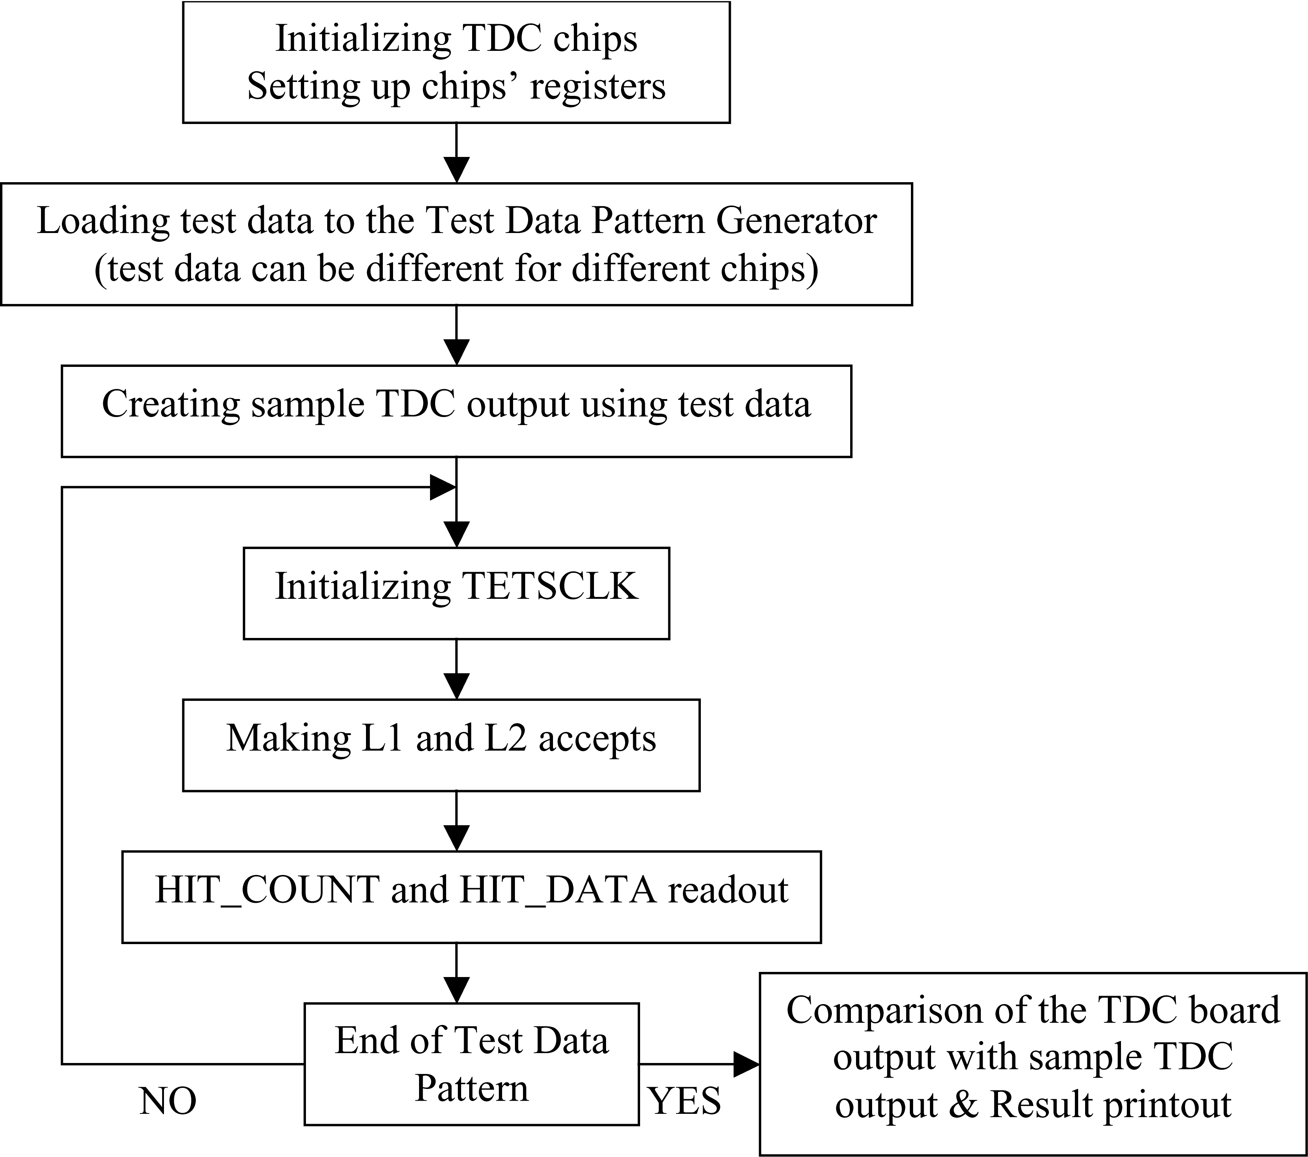
Fig. 20. ED48 test block diagram.

The TEST_DATA ram is big enough to generate 15 full events (396 ns each). The sample output is simulated by the test program after loading TETS_DATA RAM using its content. Therefore, the predicted TDC output exactly corresponds to the real TDC output. After doing L1 and L2 accepts for each event, HIT_DATA and HIT_COUNT are readout and compared bit-by-bit with the predicted TDC output. The test is passed if all the results are in bit-by-bit agreement. The test was repeated hundred times with different TEST_RAM hit patterns. If any error occurs the debug message is printed out.

The TDC XFT block test

The TDC XFT block test is similar to ED48 test since it uses the same principles. The block-schema of the test is shown below. Actually the ED48 and the TDC XFT tests are implemented together in a single subroutine since most of procedures are the same. The differences are only in the output simulation, readout and comparison routines.

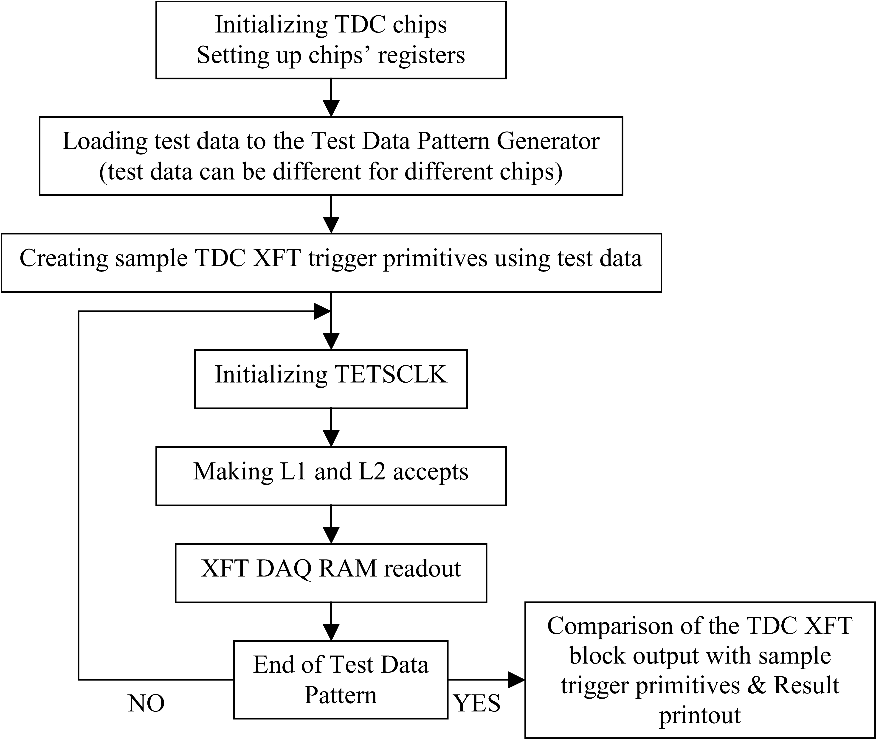
Fig. 21. XFT test block diagram

The CBLT32/64 test

The CBLT 32/64 tests are used to check the CBLT32/64 VME and the back plane capability. The tests use initial content of the Level 2 buffer rams to create different output memory content of the HIT_COUNT and the HIT_DATA RAMs. This is accomplished by setting different L2 buffer length and selecting different L2 buffers by doing L2 VME Accept. Also the TDCs output is simulated using the initial L2 buffers content (that is known) by the test program. Eventually the TDCs CBLT output is compared with the simulated. After that the test is repeated again with different L2 Accepts and L2 buffer lengths. If any error occurs the debug information I sprinted out. At th end of the test the total number of errors is printed out too.
To make a CBLT readout the HIT_COUNT buffer should be readout first and number of words required for the HIT_DATA readout should be calculated. The test was performed 5*10^9 times. All results are in bit-by-bit agreement.
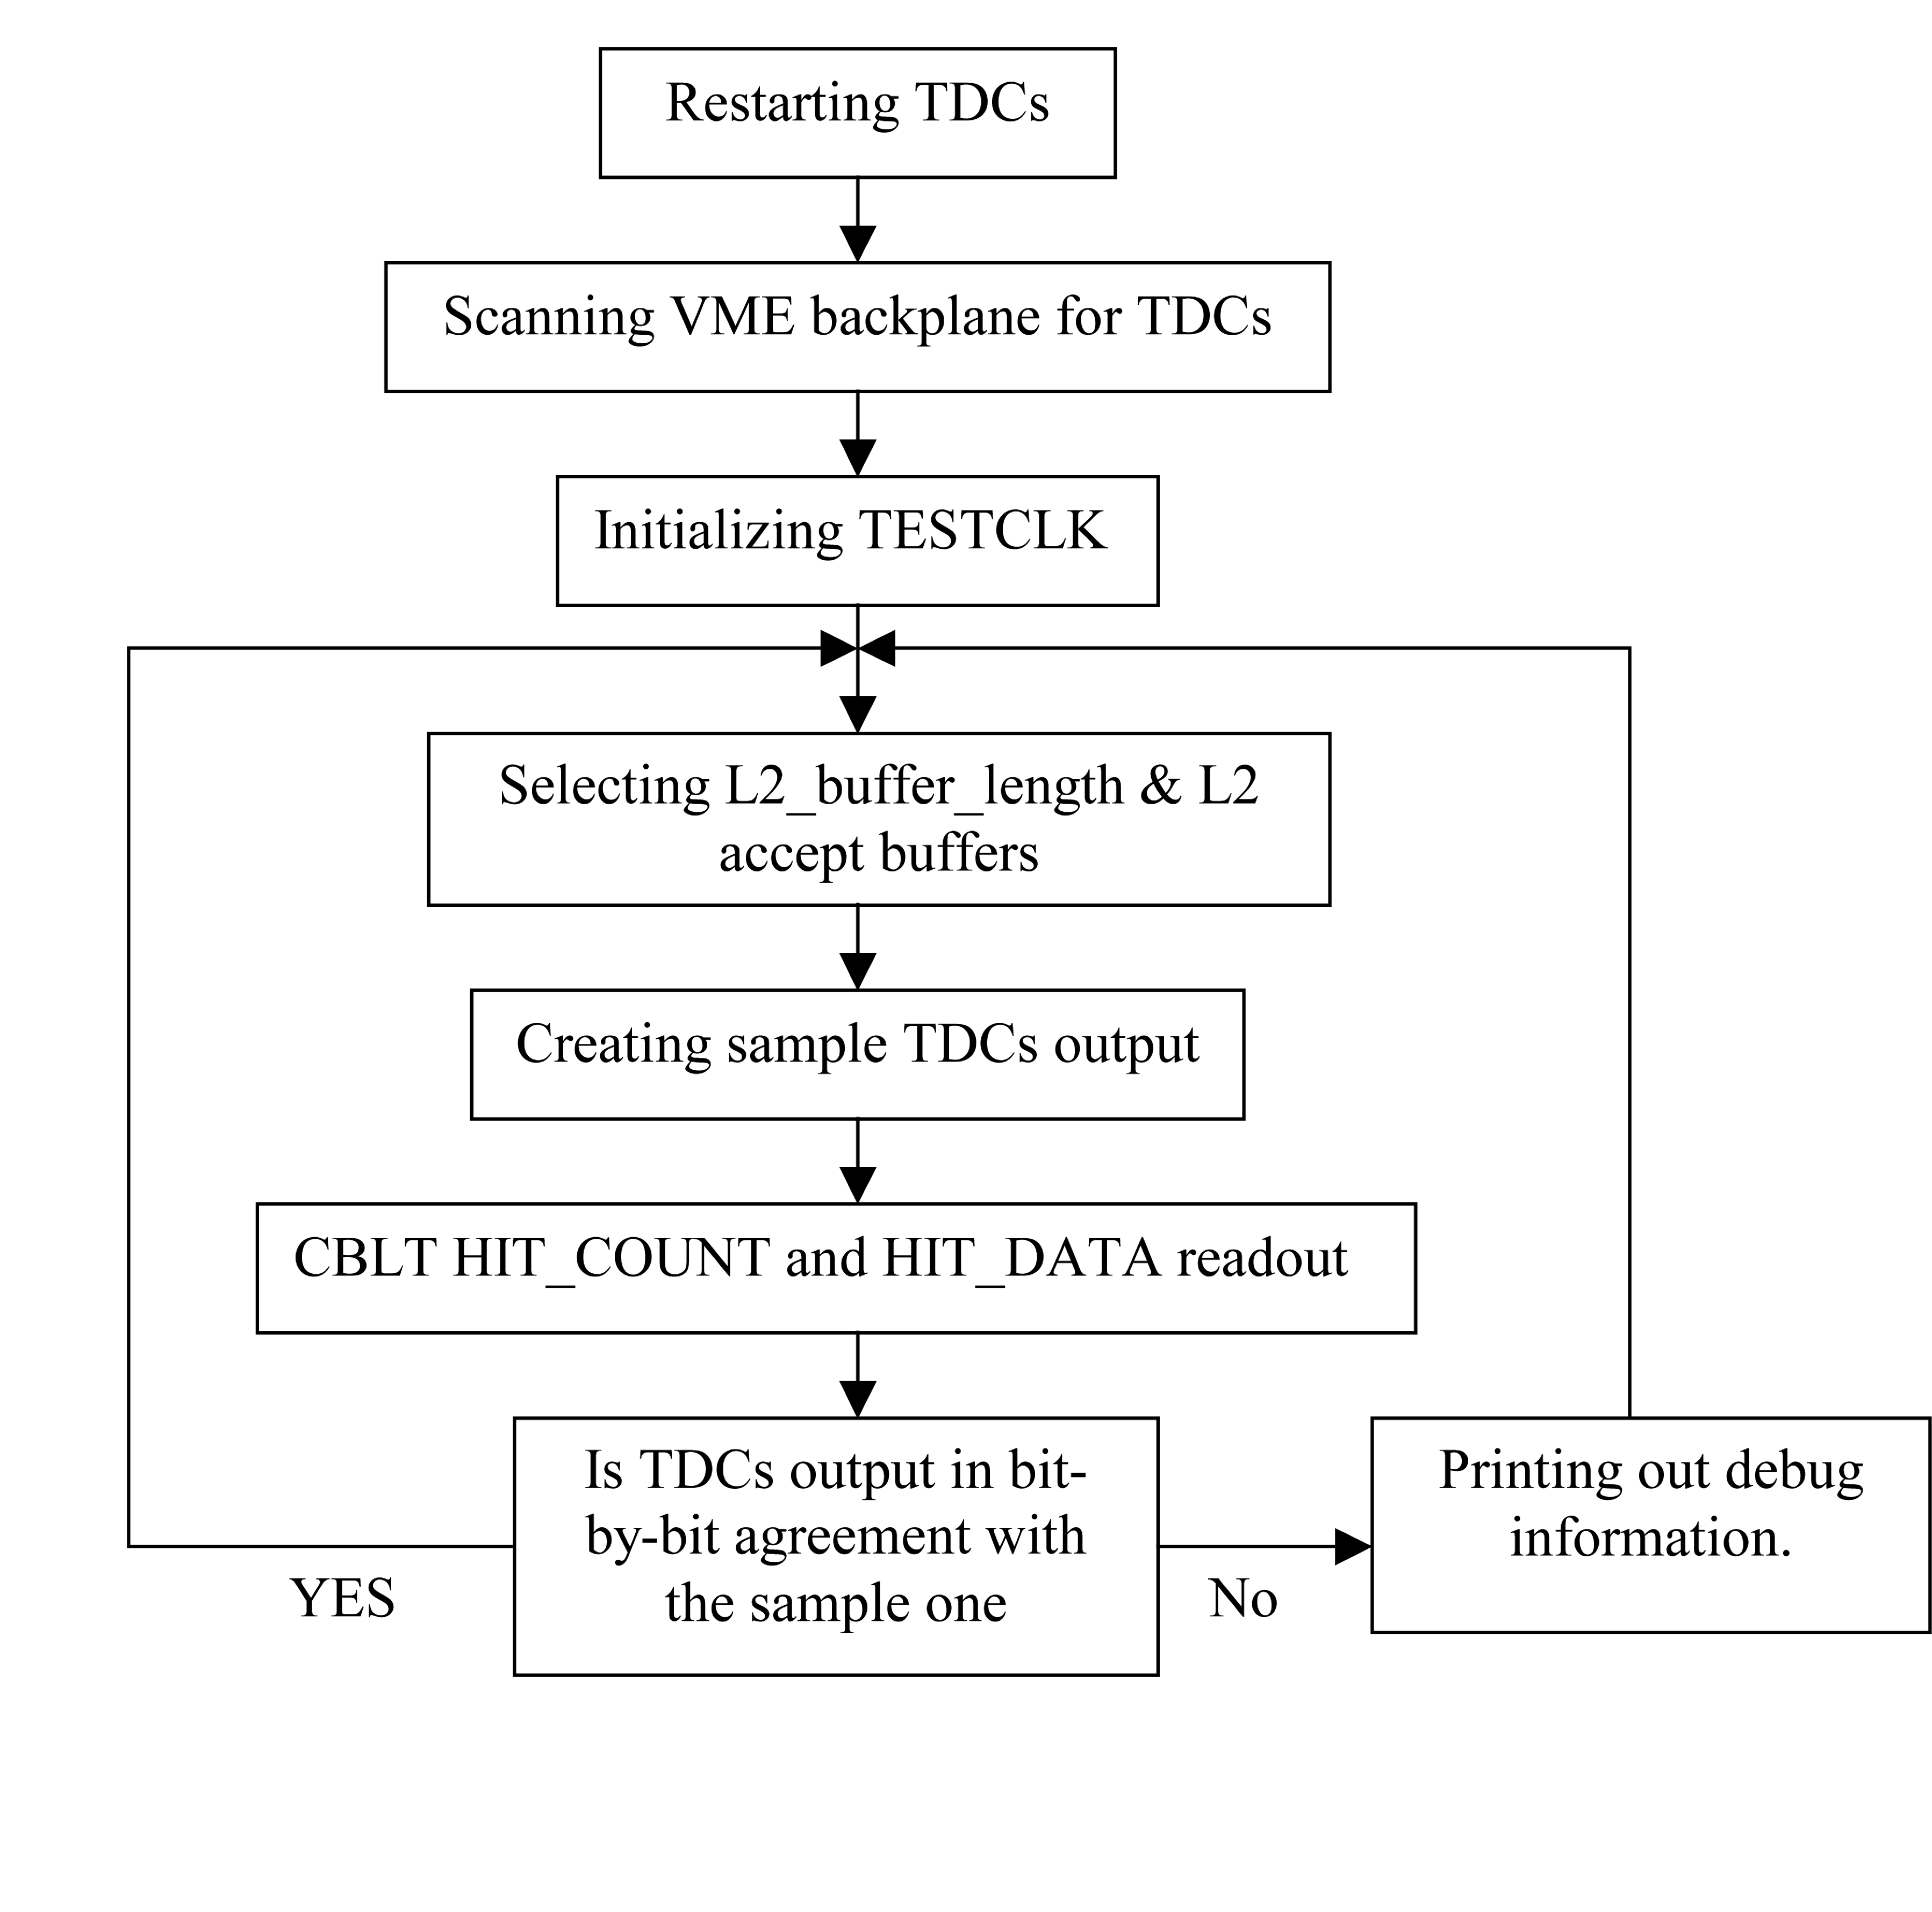
Fig. 22. CBLT test block diagram

Conclusion
Here we need a nice conclusion….we may want to put a picture of the board…

References
- Altera Corporation, “Quartus II Handbook”, ver.2.1, August 2004.
- Altera Corporation, “Stratix Device Handbook”, ver.3.0, Apr. 2004.
- T. Shaw and G. Sullivan, “A Standard Front-End Trigger VME Bus Based Readout Crate for the CDF Upgrade”, CDF/DOC/TRIGGER/CDFR/2388, May 12, 1998.
- ANSI/VITA 23-1998, Approved March 22, 1998.
- Mircea Bogdan and Harold Sanders, “Run IIB TDC-II Address Space”, CDF Note 6998, ver.0.01, June 2004.

 Manuscript received October 18, 2004. This work was supported in part by the National Science Foundation and the U.S. Department of Energy under grant number 5-43270. Mircea Bogdan is with The University of Chicago, Chicago, IL 60637 USA (telephone: 773-702-7801, e-mail: bogdan@frodo.uchicago.edu). Henry Frisch is with The University of Chicago, Chicago, IL 60637 USA (telephone: 773-702-7479, e-mail: frisch@hep.uchicago.edu). Mary Heintz is with The University of Chicago, Chicago, IL 60637 USA (telephone: 773-702-7801, e-mail: maryh@frodo.uchicago.edu). Ting Miao is with the Fermi National Accelerator Laboratory, Batavia, IL 60510 USA (telephone: 630-840-8415, e-mail: tmiao@fnal.gov). Alexander Paramonov is with The University of Chicago, Chicago, IL 60637 USA (telephone: 773-834-8971, e-mail: paramon@hep.uchicago.edu). Harold Sanders is with The University of Chicago, Chicago, IL 60637 USA (telephone: 773-702-7801, e-mail: harold@frodo.uchicago.edu). Peter Wilson is with the Fermi National Accelerator Laboratory, Batavia, IL 60510 USA (telephone: 630-840-2156, e-mail: pjw@fnal.gov).

